Lesson06- Lab Exercises - Writing Functions AIMS
To gain experience programming using the C language, with emphasis: on functions and control structures.
Objectives
When you have completed these exercises, you should be able to:
- Call a built-in function from a C library;
- Write a void function;
- Use for loop to call a function a number of times

Exercise 1 – Calling a built-in function
Read Lesson6 lecture notes page 1-2. The first example in the notes shows how to call a function from the maths library:

#include <math.h>
/* Program to demonstrate the built-in function sqrt() */ #include <stdio.h>

int main()
{
int number; float root;

printf( "Please enter a positive number : "); scanf("%d", &number);
root = sqrt( number );

printf( "The square root of %d = %f\n", number, root);

return 0;
}

Write a program Lab6ex1.c which computes a number raised to the power of 10, as follows:
- Asks the user to input a real number
- Reads in the number and stores in a double precision floating point variable
- Call the pow() function in the C math library to compute the number raised to the power of 10
- Displays the result.

Compile, link and execute the program.
Code: Log your code and run attempt here >>
/* Program to demonstrate the built-in function pow() */
#include <math.h>
#include <stdio.h>

int main()
{
int number;
double result;

printf("please enter a postive number ");
scanf("%d",&number);
// Storing the answer in result.
result = pow(number, 10);

printf("%d^10= %lf",number, result);

return 0;
}

Test Results >> (screen captures)
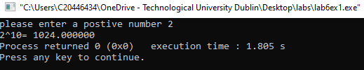
Comment on your Results – what were key learning points
- Header Files: Including necessary header files, in this case, <math.h> to access functions and features.
- Declaring variables with appropriate data types (int for number and double for result).
- Using the pow function from the math.h library to calculate the power of a number.

Exercise 2 – Writing a function to perform a simple task
Read Lesson06 of your lecture notes page 3 to 6. Consider the example program which calls a function called display_line to display a line of stars on the monitor.

/* Program to demonstrate a simple void function call*/

#include <stdio.h>

/* Function prototype. */
void display_line(void);
/* This is the function we will use in our program */

int main()

{

display_line();

/* call function to draw a line */

return 0;
}

/* Function Definition */
void display_line(void)
{

printf("* * * * * * * * * * \n");
}

• | Modify the display_line function so that it uses a for loop to display the 10 stars.
• | Modify the main function to include a for loop so that the program calls the display_line function 5 times to draws a rectangle with 5 lines of stars.
Save the program as Lab6ex2.c.
Compile, link and execute the program.
Code: Log your code and run attempt here >>
/* Program to demonstrate the built-in function sqrt()*/
#include <stdio.h>
/* Function prototype. */
void display_line(void); /* This is the function we will use in our
program */
int main()
{
printf("This program calls a function to draw a single line\n\n");
for (int i = 0; i < 10; ++i) {
display_line(); /* call function to draw a line */
}
printf("\nEnd of program\n\n");
return 0;
}
/* Function Definition */
void display_line(void)
{
printf("***********************\n");
}

Test Results >> (screen captures)
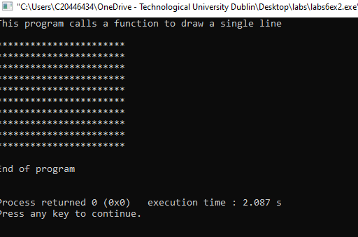

Comment on your Results – what were key learning points
- 1.The code demonstrates the use of a function prototype (void display_line(void);) to declare a function before its actual implementation.
- Function Call: The display_line function is called from the main function using display_line();.
- Looping with for Loop:The for loop is used to iterate 10 times (for (int i = 0; i < 10; ++i)). Inside the loop, the display_line function is called, which prints a line of asterisks.

Exercise 3 – Pass data to a function
Read Lesson06 of your lecture notes page 7 to 8. Consider the example program which calls a void function called beep_n_times. This function when called will repeat a task n times using a for loop to control the number of repetitions.

#include <stdio.h>

/* Function prototype.*/
void beep_n_times(int n);

int main()
{

int x = 0;

printf("Please enter number of beeps: ");
scanf("%d", &x);

/* call function make a beep, pass one argument x */

beep_n_times(x);

return 0;

}
/* Function Definition */
void beep_n_times(int n)

{

int i;
for( i=1; i<=n; i++)

{

printf(
"Beep!!\a\n");
}
}

Review this example and your code from Lab6ex2.c then write a new program Lab6ex3.c that draws a rectangle.
The program should contain three functions:
- The main function asks the user to input the width and height of the rectangle, then calls the draw_rectangle function passing it the width and height values.
- The draw_rectangle function: calls the display_line function in for loop that repeats the task a number of times dependent on the height value.
- The display_line function: modify the display_line from Lab6ex2.c so the width of the line is passed to the function and used to determine the width of the line.

Save the program as Lab6ex3.c.
Compile, link and execute the program.

Code: Log your code and run attempt here >>
#include <stdio.h>

/* Function prototypes */
void draw_rectangle(int width, int height);
void display_line(int width);

int main() {
int width, height;

// Prompt the user to input the width and height of the rectangle
printf("Enter the width of the rectangle: ");
scanf("%d", &width);

printf("Enter the height of the rectangle: ");
scanf("%d", &height);

// Call the draw_rectangle function with user-input width and height
draw_rectangle(width, height);

printf("\nEnd of program\n\n");
return 0;
}

/* Function to draw a rectangle */
void draw_rectangle(int width, int height) {
for (int i = 0; i < height; ++i) {
// Call the display_line function for each line of the rectangle
display_line(width);
}
}

/* Function to display a line with a specified width */
void display_line(int width) {
// Use the width parameter to determine the number of asterisks to print
for (int j = 0; j < width; ++j) {
printf("*");
}
printf("\n");
}

Test Results >> (screen captures)
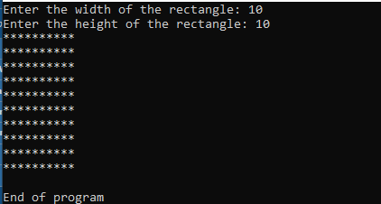

Comment on your Results – what were key learning points
- You correctly used function prototypes to declare the existence of the draw_rectangle and display_line functions before they are used in the main
- The draw_rectangle function contains a loop that calls the display_line function for each line of the rectangle.

Exercises 4
Write a C program Lab6ex4.c that displays any decimal integer 0 to 255 as a hexadecimal number 0x00 to 0xFF. [Hint – use %x format specifier with printf].
Use two functions: main() and display_hex() in this program, where
the main()function prompts the user to input a decimal integer value in the range 0 to
255 and then calls the display_hex() function which displays the number in hexadecimal.

Code: Log your code and run attempt here >>
#include <stdio.h>

/* Function prototypes */
void display_hex(int decimal);

int main() {
int decimal;

// Prompt the user for input
printf("Enter a decimal integer between 0 and 255: ");
scanf("%d", &decimal);

// Check if the entered value is within the valid range
if (decimal >= 0 && decimal <= 255) {
// Call the display_hex function to print the hexadecimal representation
display_hex(decimal);
} else {
printf("Invalid input. Please enter a decimal integer between 0 and 255.\n");
}

return 0;
}

/* Function to display the hexadecimal representation of a decimal integer */
void display_hex(int decimal) {
// Use the %x format specifier in printf to display the hexadecimal representation
printf("Decimal: %d\nHexadecimal: 0x%02X\n", decimal, decimal);
}

Test Results >> (screen captures)
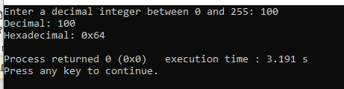

Comment on your Results – what were key learning points
- You prompt the user to input a decimal integer and validate whether it falls within the valid range (0 to 255)
- The main function calls the display_hex function, passing the user-input decimal integer.
- The display_hex function takes a decimal integer as an argument and prints its decimal and hexadecimal representations.

